Session 5: Joins and RelationshipsTrainer Coverage:Foreign keys and primary keys.Inner Join, Left Join, Right Join.Demo: Link users with their transactions table.Pending

Q:-1.Create two tables in SQL: influencers (with influencer_id as PRIMARY KEY and name) and posts (with post_id as PRIMARY KEY, influencer_id as FOREIGN KEY, and caption). Insert at least 3 influencers and 2 posts for each influencer.

Create Table Query:-
create table influencers (
influencer_id integer primary key auto_increment,
name text);

create table post(
post_id integer primary key auto_increment,
influencer_id integer,
caption text,
foreign key(influencer_id) references influencers(influencer_id));

INSERT INTO influencers(name) VALUES
('Ranveer Singh'),
('Shraddha Kapoor'),
('Vicky Kaushal');

INSERT INTO post(influencer_id, caption) VALUES
(1, 'Believe in yourself and keep moving forward.'),
(2, 'Creating beautiful memories every day.'),
(3, 'Stay positive and keep growing.');

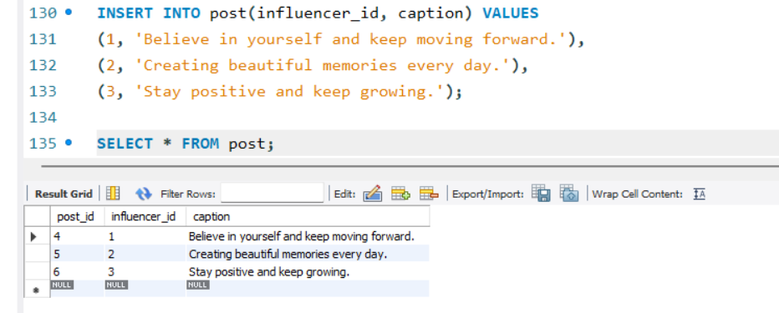

Q:-2.Write an SQL query using INNER JOIN to display each post's caption along with the name of the influencer who posted it, based on the tables you created.

select post.caption,influencers.name from post inner join influencers on post.influencer_id = influencers.influencer_id;

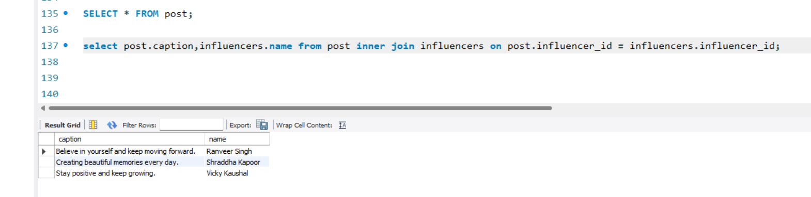
Q:-3.Write an SQL query using LEFT JOIN to show all influencers and their posts, including influencers who haven't posted anything yet. If an influencer has no posts, display 'No Posts' in the caption column.<br><br><em><strong>Hint:</strong> Use IFNULL or COALESCE to handle NULL values in the result.</em>

select i.name as influencers,coalesce(p.caption,'No posts') as caption
from influencers as i left join post as p on i.influencer_id = p.influencer_id;

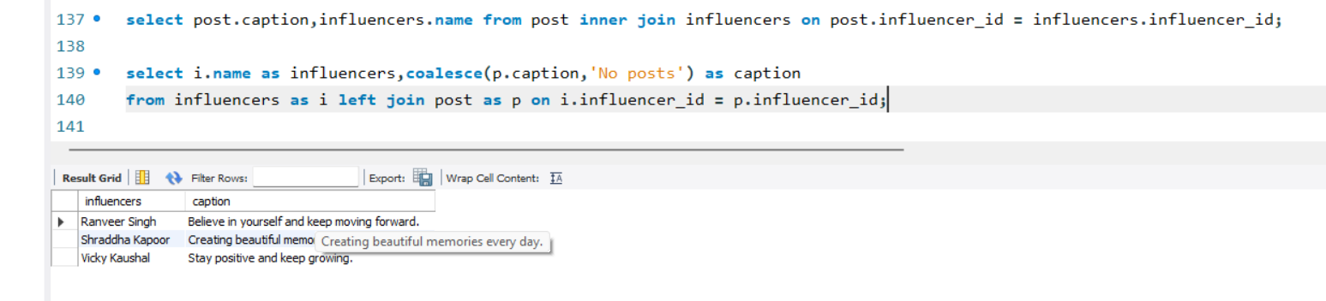

Q:-4.Write an SQL query using RIGHT JOIN to list all posts and the corresponding influencer's name, ensuring that even posts without a matching influencer_id (if any) are shown.

select p.caption,i.name AS influencer
from influencers AS i
right join post AS p ON i.influencer_id = p.influencer_id;

